**Different types of Data Types and field types**

There are different kinds of [data types](https://intellipaat.com/tutorial/java-tutorial/basic-datatypes-variables-java/) depending on conditions. There are five different data types in API –

1. ID
2. String
3. Boolean
4. Double
5. Varies by type

Different field types depending on the data types –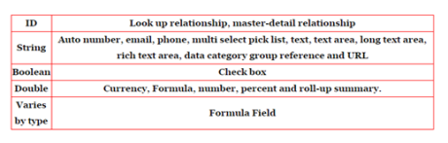

Different Field Types –

| **Field Type** | **What the Field Contains** |
| --- | --- |
| Address | A compound data type that contains address field data. |
| AnyType | Polymorphic data type that returns string, picklist, reference,  Boolean, currency, int, double, percent, ID, date, datetime, url,  or email data depending on the kind of field involved. |
| Calculated | Fields that are defined by a formula. |
| Combobox | A combobox, which includes a set of enumerated values and  allows the user to specify a value not in the list. |
| Currency | Currency values. |
| DataCategoryGroupReference | Reference to a data category group or a category unique name.. |
| Email | Email addresses. |
| Encryptedstring | Encrypted text fields contain any combination of letters,  numbers, or symbols that are stored in encrypted form. You can  set a maximum length of up to 175 characters. Available  in APIversions 11.0 and later. |
| ID | Primary key field for the object. |
| JunctionIdList | A string array of referenced ID values that represent the many-  to-many relationship of an underlying junction entity. Query  and manipulate the string array to query and manipulate the  underlying junction entities in a single API call. |
| Location | A compound data type that contains latitude and longitude  values for geolocation fields. |
| Masterrecord | When records are merged, the ID of the record that is saved  (the other records are deleted). |
| Multipicklist | Multi-select picklists, which include a set of enumerated values  from which multiple values can be selected. |
| Percent | Percentage values. |
| Phone | Phone numbers. Values can include alphabetic characters.  Client applications are responsible for phone number  formatting. |
| Picklist | Picklists, which include a set of enumerated values from which  one value can be selected. |
| Reference | Cross-references to a different object. Analogous to a foreign  key field in SQL.. |
| Textarea | String that is displayed as a multiline text field. |
| URL | URL values. Client applications should commonly display these  as hyperlinks. |